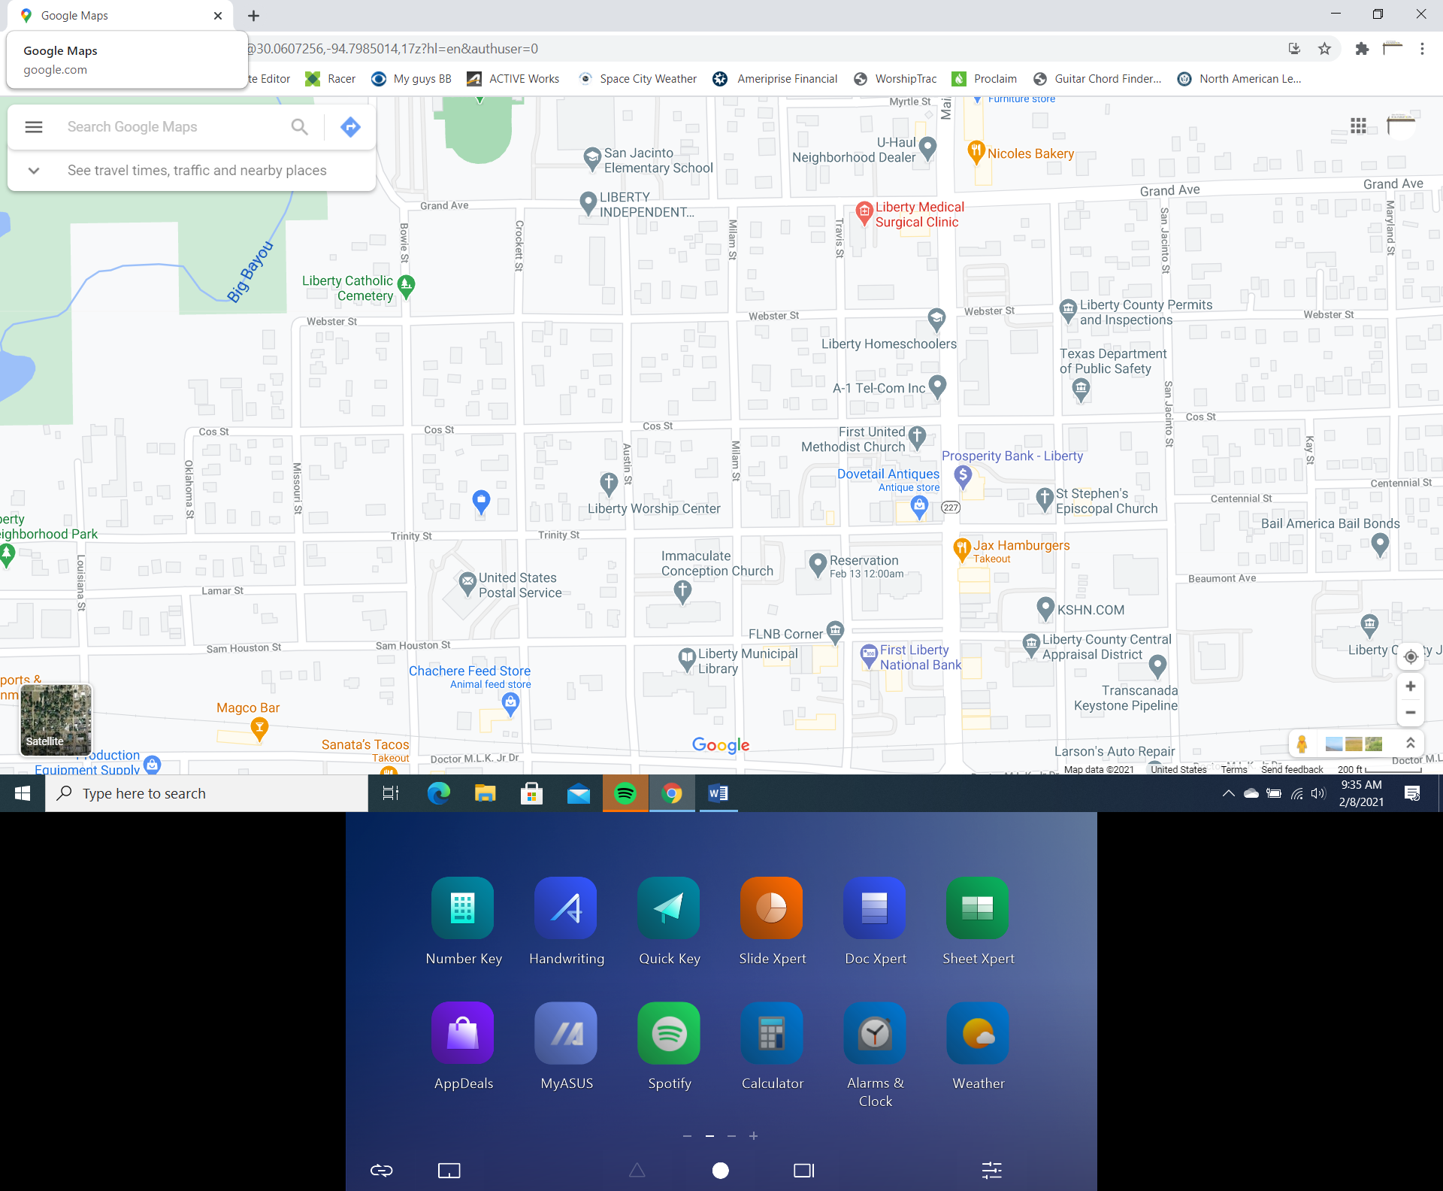

**Liberty Center**

First

Baptist Church of

Liberty

Large Parking areas in purple.

Street parking available everywhere. All are free.

Please do not park on the North or West sides of the Courthouse as there is a car show going on there.

NOT

HERE

NOT HERE